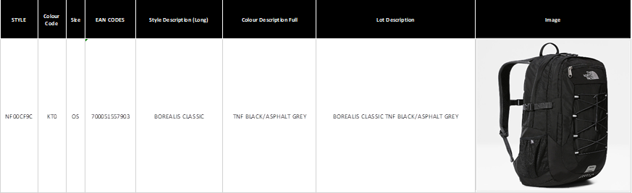

Available 2.500 pieces in black borealis classic.

Retail Price 120,00€

Full paperwork Exworks Spain